PROBLEM SHEET - ACIDS & BASES - 2

1. You have been asked to prepare 500 mL of a 0.05 mol L⁻¹ standard solution of sodium carbonate. Which of the following steps would you use in this preparation? List them in the correct order.

Dry the inside of the volumetric flask
Swirl the flask until the solid dissolves
Fill the volumetric flask with water until the level is just above the calibration mark
Weigh out 7.15 g of Na₂CO₃.10H₂O
Dissolve some sodium carbonate in water
Fill the volumetric flask with water until the top of the meniscus on the calibration mark
Transfer the sodium carbonate to a 500 mL conical flask
Wash the 500 mL volumetric flask with sodium carbonate solution
Wash the 500 mL volumetric flask with distilled water
Put the stopper on and shake the volumetric flask
Weigh out 2.08 g of hydrated sodium carbonate
Weigh out 2.65 g of anhydrous sodium carbonate
Fill the volumetric flask with water until the bottom of the meniscus on the calibration mark
Shake the flask violently to dissolve the solid
Transfer all the sodium carbonate solid to the volumetric flask
Add some distilled water to the flask

2. A student prepared a standard solution of oxalic acid, H₂C₂O₄.2H₂O in a 500 mL volumetric flask. She recorded the
following measurements:
mass of weighing bottle + oxalic acid = 48.93 g
mass of weighing bottle + traces of oxalic acid
left after transferring the rest to the volumetric flask = 42.57 g

Calculate the concentration of the oxalic acid solution.

3. The preparations of several solutions are described below.

For each state whether you think the concentration calculated from the given mass data would be accurate. If it is not accurate then state whether the true concentration is higher or lower than this calculated concentration.

A. Preparation of a solution of sodium hydroxide
With some difficulty, a sample of sodium hydroxide, of mass 3.98 g was weighed. All of this sample was then transferred to a 1.00 L volumetric flask. Water was added to the flask up to the calibration mark. The solution was then thoroughly shaken.
The concentration of this sodium hydroxide solution, calculated from the mass and volume data given above, is 0.0995 mol L⁻¹.

B. Preparation of a solution of sodium carbonate
A sample of solid hydrated sodium carbonate was weighed out. The mass of the solid was 1.45 g. This solid was dissolved in water and all of the solid plus water was added to a 500 mL volumetric flask. Then water was added to make 500 mL of solution. The mixture was shaken thoroughly.
The concentration of this solution was calculated assuming the formula of hydrated sodium carbonate is Na₂CO₃.10H₂O. The calculated concentration was 0.0101 mol L⁻¹.

4. The percentage of ammonia is a sample of window-cleaner liquid was determined using volumetric analysis. 20.6 g of the window-cleaner liquid was first diluted with water by making it up to 250 mL in a volumetric flask. 25.0 mL aliquots of this diluted solution were then titrated with a standard solution of hydrochloric acid, using an appropriate indicator. The concentration of the hydrochloric acid was 0.124 mol L⁻¹.

The following results were obtained:
Volume of HCl: final burette reading: 45.60 mL 36.25 mL 27.90 mL 42.50 mL
initial burette reading: 25.70 mL 17.10 mL 8.85 mL 23.20 mL

a) What would you rinse the following equipment with, just prior to use in the above titration?
i) volumetric flask ii) the 25.0 mL pipette
iii) the burette iv) the conical flask into which the diluted ammonia solution is pipetted.
b) Calculate the percentage, by mass, of ammonia in the window-cleaning liquid.

5. In a titration to determine the concentration of a solution of potassium hydroxide, 20 mL of the KOH solution was pipetted into a conical flask. An indicator was then added. The solution was titrated with a solution of HCl contained in a burette. The pH of the solution at the equivalence point is 7.0.

a) Why is the pH of the solution at the equivalence point equal to 7.0?

Indicator | Colour |  | pH range of
 | Acid | Base | colour change
Methyl violet  Methyl orange  Litmus  Bromothymol blue  Phenol red  Phenolphthalein  Alizarin yellow | Yellow  Red  Red  Yellow  Yellow  Colourless  Yellow | Violet  Yellow  Blue  Blue  Red  Pink  Red | 0.0 - 1.6  3.2 - 4.4  5.0 - 8.0  6.0 - 7.6  6.6 - 8.0  8.2 - 10.0  11.1 - 12.0

b) From the table, choose an indicator that would have a suitable end point for this titration.
c) Using the indicator chosen in b)
i) what colour would the indicator initially be when added to the conical flask?
ii) to what colour would the indicator change at the end-point?
d) When a suitable indicator is used for the titration, the average titre of hydrochloric acid used was
found to be 20.2 mL.
What would be the effect on the volume of acid required for the titration if
i) methyl violet was used as the indicator?
ii) alizarin yellow was used as the indicator?

6. You are required to determine the concentration of a solution of hydrochloric acid using anhydrous sodium carbonate as a primary standard.
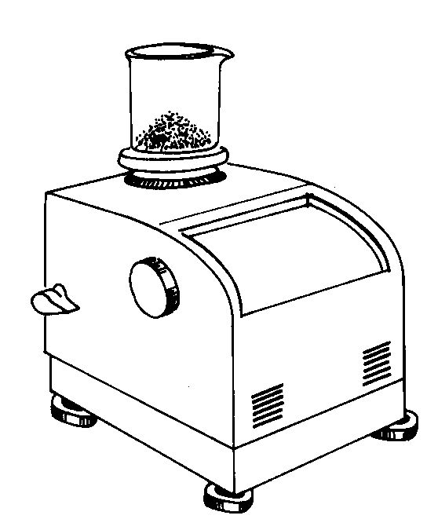
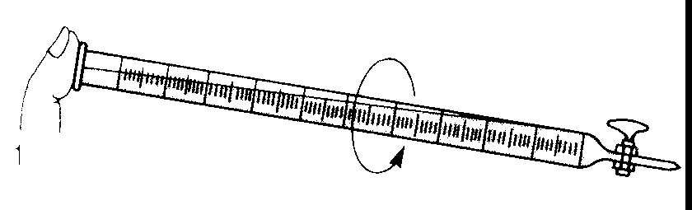
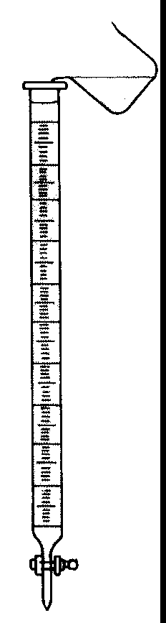
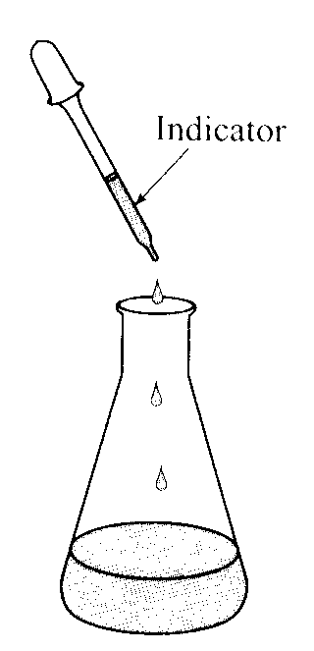
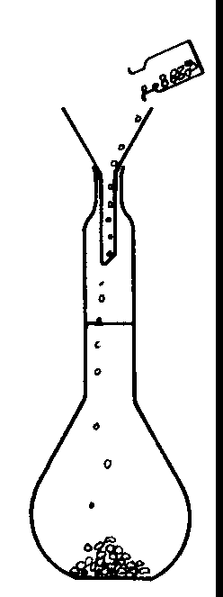
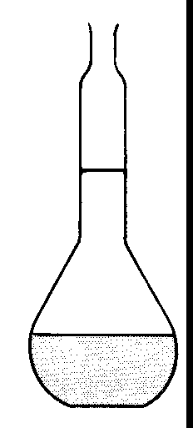
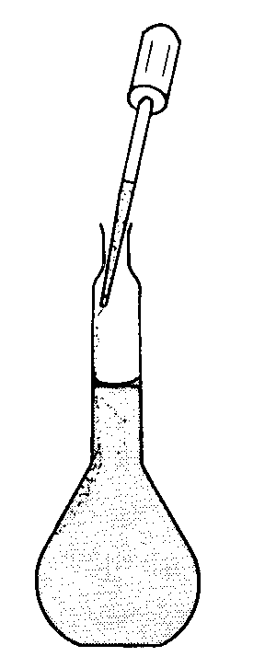
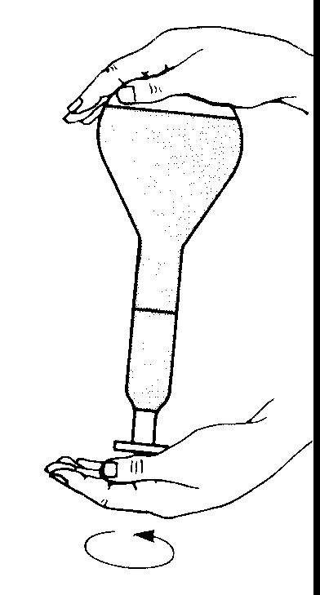
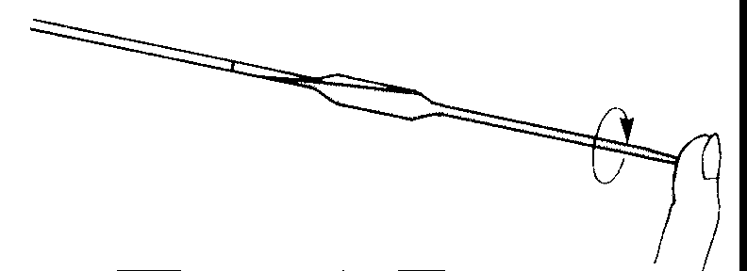
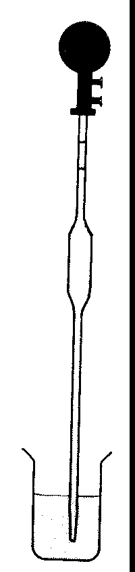
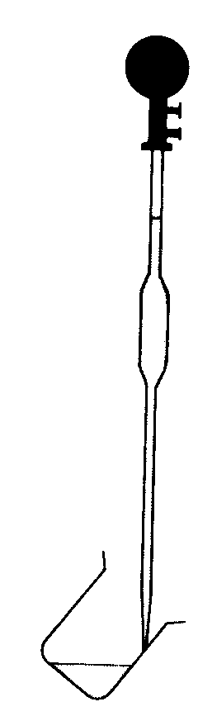
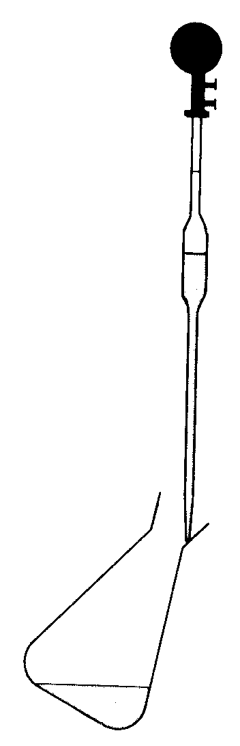
In which order would you carry out the following tasks?

7. a) What substances are present and what is the approximate pH of the solution at the equivalence point
of titrations involving the following 0.1 mol L⁻¹ acids and bases?
i) sodium hydroxide and ammonium chloride
ii) potassium hydroxide and nitric acid
iii) hydrochloric acid and sodium carbonate
iv) nitric acid and ammonia solution
v) sodium hydroxide and acetic acid

b) Which indicator would be suitable for each titration, methyl orange or phenolphthalein?

8. Write ionic equations for the following reactions:

a) Dilute hydrochloric acid is added to zinc

b) Calcium carbonate is added to a solution of hydrochloric acid

c) Dilute hydrochloric acid is added to a solution of sodium sulfide

d) A solution of hydrochloric acid is added to magnesium oxide

e) A solution of potassium sulfite is mixed with a solution of hydrochloric acid

f) Sodium hydrogencarbonate is added to a solution of hydrochloric acid

g) Ammonia solution is added to hydrochloric acid solution.

h) Sulfur is burnt in air

i) Copper is added to hot concentrated sulfuric acid

j) Ammonia gas is bubbled through a solution of sulfuric acid

k) Aluminium oxide is added to sulfuric acid solution

9. Give ionic equations for the following reactions:
a) aluminium hydroxide is added to a solution of sodium hydroxide

b) solid magnesium hydroxide with a solution of sodium hydroxide

c) a solution of sodium hydroxide (in excess) with a solution of zinc nitrate

d) a solution of copper sulfate with a solution of sodium hydroxide

e) a solution of sodium hydroxide with chromium

f) aluminium oxide with a solution of sodium hydroxide

g) a solution of ammonia with a solution of magnesium nitrate

h) aqueous solutions of ammonia and aluminium nitrate

i) a solution of ammonia (in excess) with a solution of copper sulfate

9. j) a solution of ammonia (in excess) with a solution of zinc nitrate

k) a solution of ammonia with silver oxide

ANSWERS
1. Wash the 500 mL volumetric flask with distilled water
Weigh out 2.65 g of anhydrous sodium carbonate
Transfer all the sodium carbonate solid to the volumetric flask
Add some distilled water to the flask
Swirl the flask until the solid dissolves
Fill the volumetric flask with water until the bottom of the meniscus on the calibration mark
Put the stopper on and shake the volumetric flask
2. moles of oxalic acid = 6.36/126.1 = 0.05044 conc = 0.05044/0.500 = 0.101 mol L⁻¹
3. A - the concentration will not be accurate because as the NaOH is weighed, it will absorb water. The mass of 3.98 g will therefore include some water. The true concentration of NaOH will be less than the calculated concentration.
B - hydrated sodium carbonate rarely contains 10 water molecules for every Na₂CO₃ unit. It often contains less water of crystallisation. Consequently, the concentration will probably not be accurate; the true concentration
will probably be more than the calculated concentration.
4. a) i) distilled water ii) dilute window-cleaner liquid iii) HCl iv) distilled water
b) average of concordant results = ( 19.15 + 19.05)/2 = 19.10mL
moles of HCl used = 0.124 x 0.01910 = 0.002368 NH₃ + H₂ → NH₄⁺
moles of ammonia in 25.0 mL aliquot = 0.002368
moles of ammonia in the 250 mL solution = 0.002368 x 250/25 = 0.02368
= moles of ammonia in 20.6 g of window cleaner liquid
mass of ammonia in 20.6 g of window-cleaner liquid = 0.02368 x 17.03 = 0.4034 g
percentage of ammonia in window-cleaner liquid = 0.4034/20.6 x 100 = 1.96%
5. a) At the equivalence point, only water and NaCl are present in the flask. Na⁺ and Cl⁻ ions are neutral, and so the
solution will be neutral i.e. pH of 7
b) Bromothymol blue (or phenol red)
c) i) blue (or red) ii) yellow (or yellow)
d) i) larger volume of HCl will be used ii) smaller volume of HCl will be used
6. Weigh out sodium carbonate
Transfer sodium carbonate to volumetric flask
Dissolve sodium carbonate in water
Add water to make solution up to calibration mark
Shake solution thoroughly
Rinse burette with hydrochloric acid solution
Fill washed burette with hydrochloric acid
Rinse pipette with sodium carbonate solution
Draw in sodium carbonate solution above mark
Run sodium carbonate solution down to calibration mark and touch end on edge of container
Run sodium carbonate solution from pipette into conical flask
Add 2-3 drops of indicator
Add, from the burette, the volume of HCl needed to reach the end-point

7. a) i) sodium chloride ammonia, and water - pH of about 9 (weak base)
ii) potassium nitrate and water - pH of about 7 (neutral)
iii) sodium chloride, carbon dioxide and water - pH of about 5 (weak acid)
iv) ammonium nitrate and water - pH of about 5 (weak acid)
v) sodium acetate and water - pH of about 9 (weak base)
b) i) phenolphthalein ii) either iii) methyl orange iv) methyl orange v) phenolphthalein

8. a) Zn + 2H⁺ → H₂ + Zn²⁺
b) CaCO₃ + 2H⁺ → CO₂ + H₂O + Ca²⁺
c) 2H⁺ + S²⁻ → H₂S
d) MgO + 2H⁺ → H₂O + Mg²⁺
e) SO₃²⁻ + 2H⁺ → SO₂ + H₂O
f) NaHCO₃ + H⁺ → CO₂ + H₂O + Na⁺
g) NH₃ + H⁺ → NH₄⁺
h) S + O₂ → SO₂
i) Cu + 4H⁺ + SO₄²⁻ → Cu²⁺ + SO₂ + 2H₂O
j) NH₃ + H⁺ → NH₄⁺
k) Al₂O₃ + 6 H⁺ → 2Al³⁺ + 3H₂O

9. a) Al(OH)₃ + OH⁻ → Al(OH)₄⁻
b) no reaction
c) Zn²⁺ + 4 OH⁻ → Zn(OH)₄²⁻
d) Cu²⁺ + 2 OH⁻ → Cu(OH)₂
e) 2Cr + 2 OH⁻ + 6H₂O → 3H₂ + 2Cr(OH)₄⁻
f) Al₂O₃ + 2 OH⁻ + 3 H₂O → 2Al(OH)₄⁻
g) Mg²⁺ + 2 OH⁻ → Mg(OH)₂
h) Al³⁺ + 4 OH⁻ → Al(OH)₄⁻
i) Cu²⁺ + 4NH₃ → Cu(NH₃)₄²⁺
j) Zn²⁺ + 4NH₃ → Zn(NH₃)₄²⁺
k) Ag₂O + 2NH₃ + H₂O → 2Ag(NH₃)₂⁺ + 2 OH⁻

